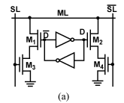
NOR Cell
- The NOR cell implements the comparison between the complementary stored bit, D (and $\overline{D}$), and the complementary search data on the complementary searchline, SL (and $\overline{SL}$), using four comparison transistors, M1 through M4, which are all typically minimum-size to maintain high cell density
- The NOR nature of this cell becomes clear when multiple cells are connected in parallel to form a CAM word by shorting the ML of each cell to the ML of adjacent cells.
- There is a match condition on a given ML only if every individual cell in the word has a match.

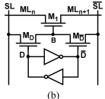
NAND Cell
- The NAND cell implements the comparison between the stored bit, D, and corresponding search data on the corresponding searchlines, (SL, $\overline{SL}$), using the three comparison transistors M1, M_{D}, and $M_{\overline{D}}$, which are all typically minimum-size to maintain high cell density.
- The NAND nature of this cell becomes clear when multiple NAND cells are serially connected.
- It provides a full rail voltage at the gates of all comparison transistors. It provides a reduced logic “1” voltage at node B, which can reach only V_{DD} - V_{Tn} when the searchlines are driven to V_{DD}.

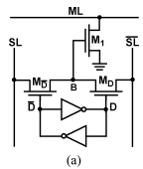
Cell Variant of NOR
- The NOR cell variant [Fig. a] uses only 9-transistors compared to the previous 10-T NOR cell.
- Although, this 9-T NOR cell has only a single transistor in the pulldown path, the node B can only rise to V_{DD} - V_{Tn} so usually the 10-T NOR cell is preferred.

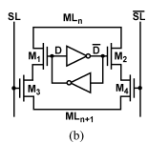
Cell Variant of NAND
- The 10-T NAND cell [Fig. b] is a variant of the previous 9-T NAND cell.
- Since this NAND cell doubles the number of transistors in series, the 9-T NAND is usually preferred.

NOR Matchline
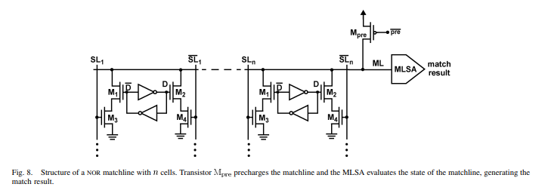

NAND Matchline
